Media release: 14 April 2022

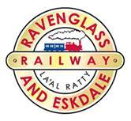

**Steam Gala returns to iconic Lake District Railway with special three-day event**

**One of the UK’s best-loved heritage railway lines is preparing to put on a spectacular steam show, as the Ravenglass & Eskdale Railway has announced the return of their annual ‘May Gala Weekend’ with an exciting three-day event.**

***‘Everything Goes!’*** is a fitting theme for this year’s special gala, as the Railway has planned a jam-packed weekend with all nine of their working steam and diesel locomotives out and about, across May Bank Holiday (30 April – 2 May).

This includes the *River Esk,* which is set to celebrate a huge centenary milestone next year, plus the *River Irt*, which is the oldest working 15-inch gauge locomotive in the world.

The beautifully restored 125-year old *Katie* will be featured, along with *Les,* a Lister diesel built in the 1960’s*,* which will be out pulling passenger trains for the first time in more than twenty years! The Railway will also be welcoming special guest visitors including the traction engine *Providence,* which will be the star of the show.

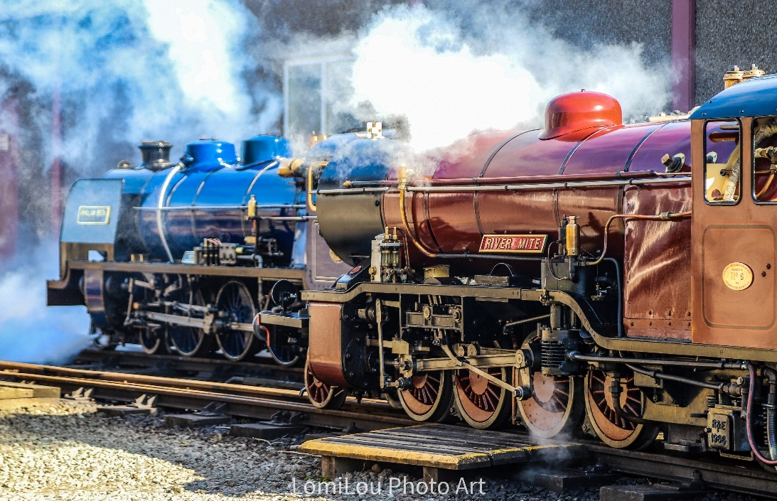Tickets are available to purchase online at [www.ravenglass-railway.co.uk](http://www.ravenglass-railway.co.uk) for the Gala, which will take place at Ravenglass & Eskdale Railway from **Saturday 30th April until Monday 2nd May 2022.**

Visitors can marvel at the exquisite vintage vehicles on display at Ravenglass, or step back in time at the free-to-enter Ravenglass Railway Museum, with fantastic displays, model trains and interactive features that celebrate 150 years of La’al Ratty.

It’s a great chance to visit the special exhibition on the recently restored Pullman Camping coaches, *Elmira and Maid of Kent*, including genuine Pullman objects on loan from the Pullman Society.

**Stuart Ross, General Manager (Visitor Experience) at Ravenglass & Eskdale Railway** says, *“*

“Our annual gala is always a fantastic weekend for all, and we are delighted to see it’s return after the last few years of restrictions and disruptions. This year we have pulled out all the stops, and visitors are sure to be impressed as we have all nine of our working engines on show plus special guest appearances.”

“It’s a great chance for families and railway enthusiasts alike to relive the era of steam travel, whilst enjoying the beautiful vistas of Cumbria’s west coast and dramatic mountain ranges.”

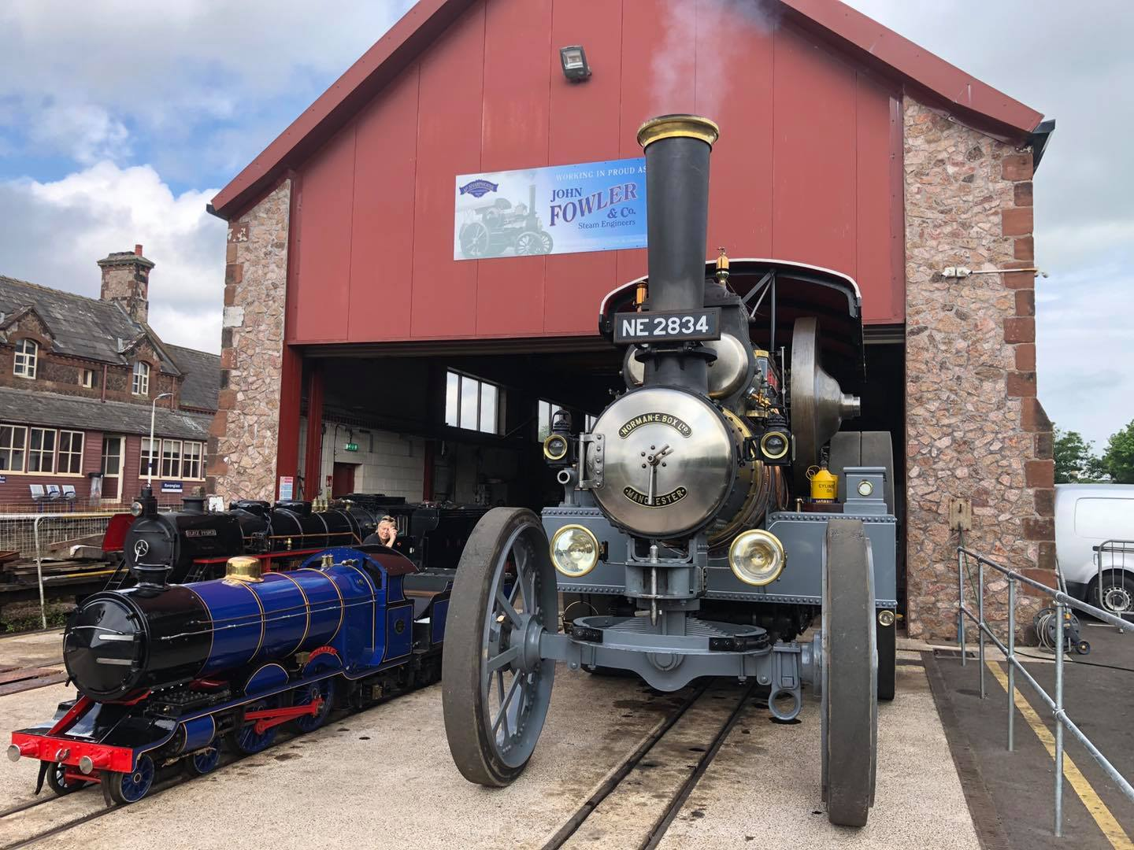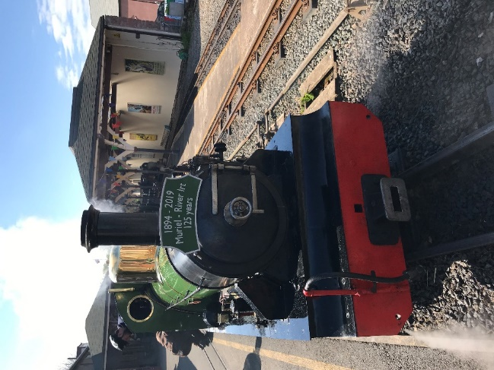

Passengers can view the timetable and [**book tickets online**](https://ravenglass-railway.co.uk/events/) for the 2022 May Gala Weekend.

**ENDS**

**Notes to Editors:**

For further information and media enquiries, please contact: **Cumbria Tourism Bespoke PR,**   
Holly Collins, [hcollins@cumbriatourism.org](mailto:hcollins@cumbriatourism.org) / 07766985993

Hi-res images attached:

* River Esk, credit: Mark Fielding
* River Mite, Rosalind Goodman
* River Irt
* Traction Engine

2022 May Gala – Engine Details:

* **Steam Engines** River Irt, River Esk, River Mite, Katie, Whillan Beck
* **Diesel Engines** Douglas Ferreira, Lady Wakefield, Perkins, Cyril
* **Special guests:**
  + *Les,* Lister diesel engine
  + Traction engine *Providence* courtesy of the Stafford Bros – special guest star.
  + Miniature railway courtesy of Stuart Harrison.
  + Rolls Royce car courtesy of Stuart Harrison.
  + Road steam Traction engines from the John Fowler Engineering base at Bouth, courtesy of Alex Sharphouse